EHDP Data Lineage

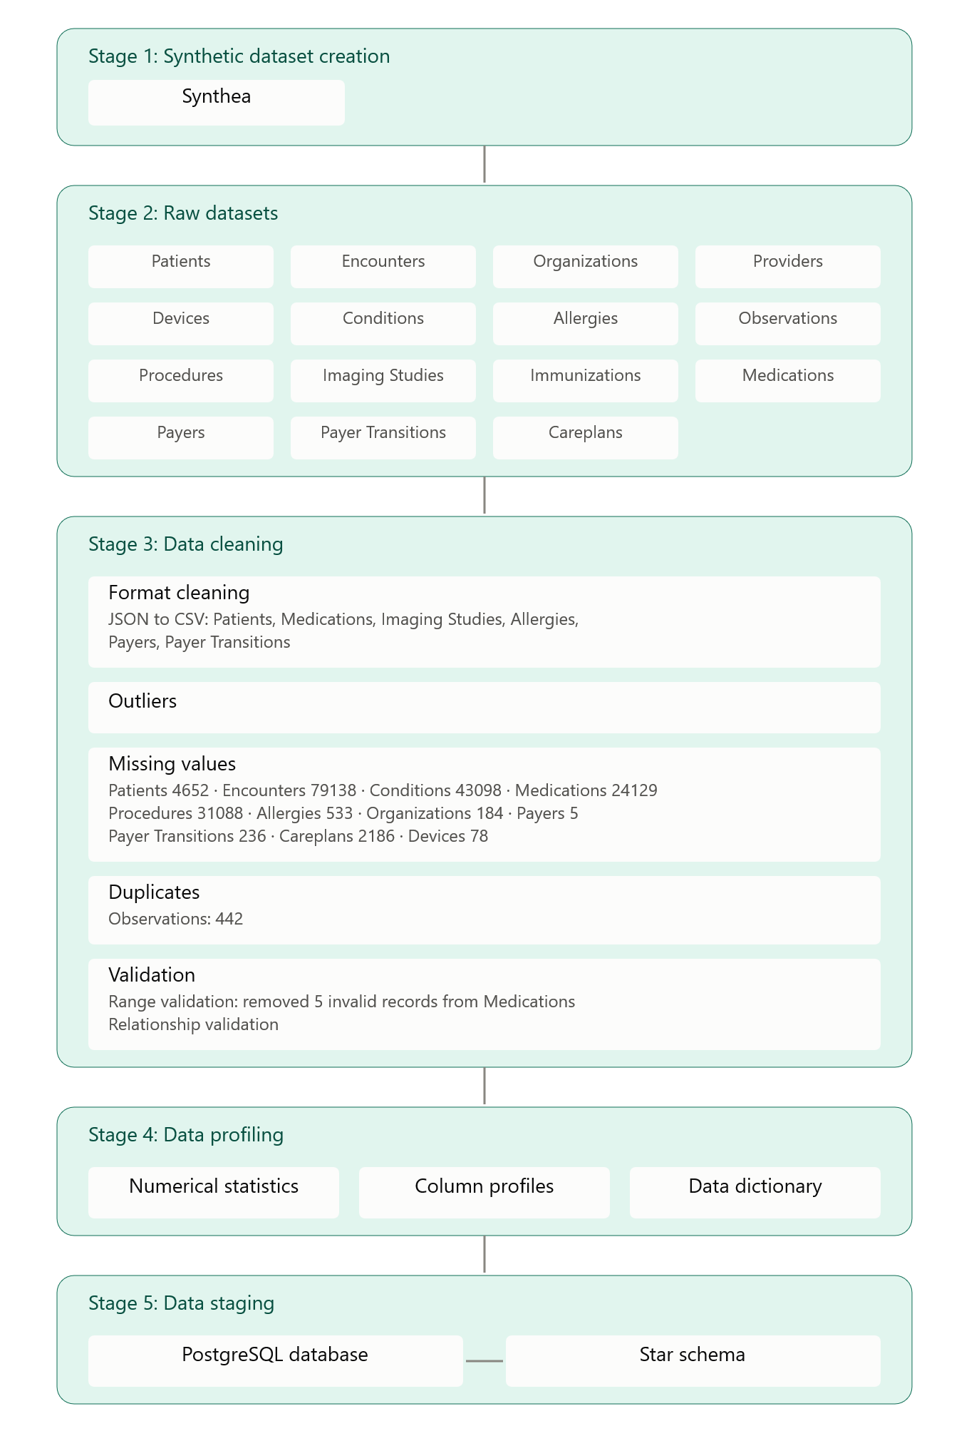

Stage 1: Synthetic Dataset Creation
The Synthea platform is used to generate bulk amounts of simulated healthcare data that closely resembles clinical and operational records. 15 datasets in total are extracted.

Stage 2: Raw Datasets
We get 15 different datasets representing a particular dimension of healthcare data:
- Encounters (patient appointments)
- Patients (patient data)
- Organizations (hospitals and healthcare facilities)
- Providers (healthcare practitioners who treat patients)
- Payers (health insurance providers)
- Payer Transitions (patient insurance plans)
- Conditions (patients' chief complaints)
- Allergies (presence of allergic condition in patient)
- Observations (measurements taken in medical tests)
- Procedures (medical tests conducted in diagnosis)
- Imaging Studies (data of medical scans)
- Devices (machines used in diagnoses and treatment)
- Careplans (treatment procedures prescribed to patient)
- Medications (medicines and drugs prescribed to patient)
- Immunizations (vaccines taken)

Stage 3: Data Ingestion and Cleaning
All of the datasets are ingested into Pentaho for corrective transformation. The following preprocessing procedures are conducted before data warehousing:
1. Format Standardization - Any JSON datasets are converted to CSV format for more organized structure.
2. Missing Value Detection - More than 100,000 missing values were found in the datasets, mostly in columns deliberately left incomplete and optional like date of death in Patients and stop date in Allergies to represent chronicity.
3. Duplicate Removal - 442 duplicate records were found in the Observations table and deleted.
4. Outlier Detection - to identify anomalies in datasets that may affect the outputs of dashboards and statistical analyses.
5. Data Validation - Validate prescribed range of features and relationships between tables; 5 records in Medications were removed because the stop date came before the start date.

Stage 4: Data Staging
From Pentaho, the cleaned datasets are loaded to a PostgreSQL database at the end of an extensive ETL procedure to preprocess the data. The datasets are organized into a star schema that establishes and maintains the relationships between pairs of datasets.

